Week 1 – IOC Collection and Normalization

1. Introduction
The first week focused on building the Threat Intelligence collection and normalization component of the project.
The main objective was to collect Indicators of Compromise (IOCs) from multiple open threat intelligence sources, normalize the collected data into a common structure, remove duplicate indicators, and store the final dataset in a centralized SQLite database.
Three threat intelligence sources were used:
- ThreatFox
- URLhaus
- AlienVault OTX
The resulting database will be used as the main threat intelligence dataset for the following stages of the project.

2. IOC Collection
IOC data was collected from three different threat intelligence platforms: ThreatFox, URLhaus, and AlienVault OTX.
Each source provides threat intelligence using a different data structure and different types of indicators. The collected data was initially stored in its raw JSON format to preserve the original information before processing.
Figure 1. Final IOC source distribution across ThreatFox, URLhaus, and AlienVault OTX.

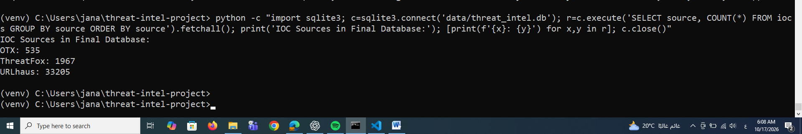

3. IOC Normalization and Deduplication
After collecting the raw data, a normalization process was applied to convert the indicators from the different sources into a common structure.
The normalized records contain common fields such as:
- IOC value
- IOC type
- Source
- Threat type
- Malware
- Confidence
- First seen
- Last seen
- Reporter
- Tags
After normalization, duplicate indicators were removed using the IOC value and IOC type as the uniqueness criteria.
Figure 2. IOC normalization and deduplication process.
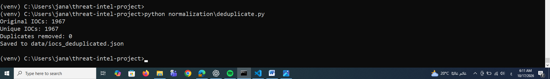

4. IOC Merging
The normalized datasets from ThreatFox, URLhaus, and OTX were then merged into a single IOC collection.
Cross-source deduplication was also performed during the merging process to prevent repeated indicators from being stored unnecessarily.
The final merged dataset contained 35,707 unique IOCs.
Figure 3. Merging the normalized IOC datasets from the three sources.
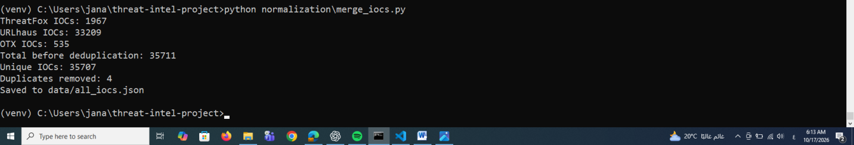

5. IOC Database
The final IOC dataset was stored in an SQLite database named threat_intel.db.
The database contains a dedicated iocs table with information about the IOC value, type, source, threat type, malware, confidence, timestamps, reporter, and tags.
The final database contains 35,707 IOC records, distributed across the three sources as follows:
Source | Number of IOCs
URLhaus | 33,205
ThreatFox | 1,967
OTX | 535
Total | 35,707
Figure 4. Final IOC database validation and distribution.
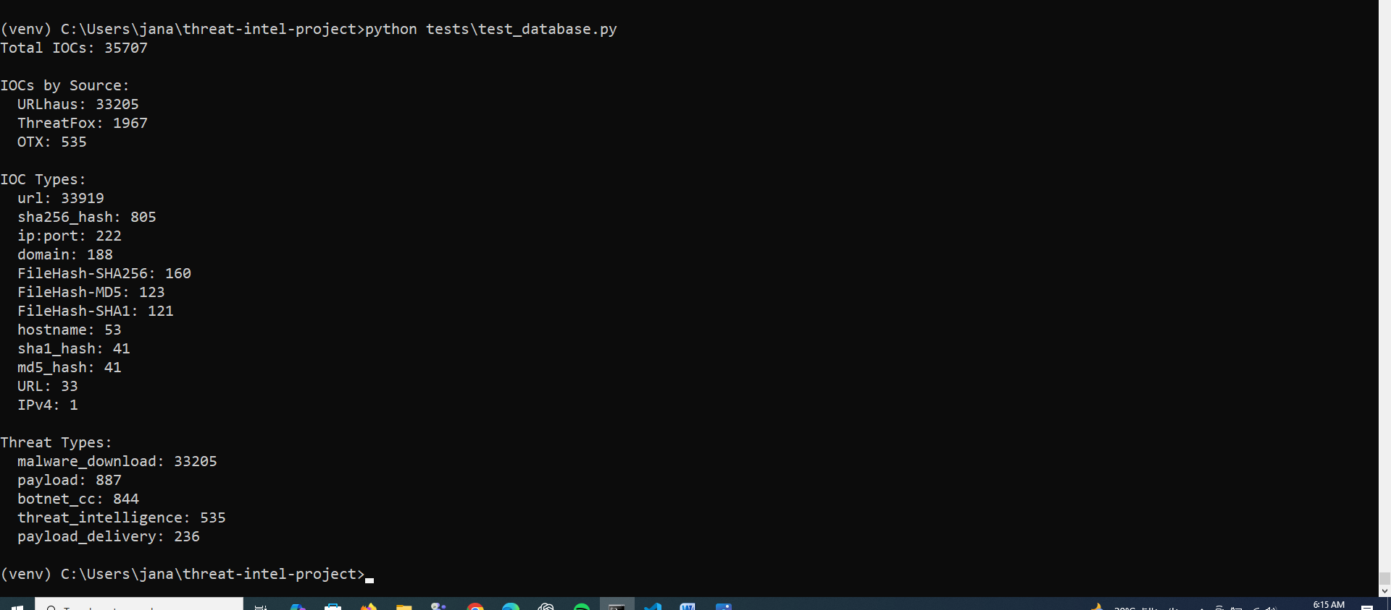

6. Week 1 Results
The main outcomes of Week 1 were:
- Successful collection of IOCs from three threat intelligence sources.
- Normalization of source-specific IOC data into a common structure.
- Removal of duplicate indicators.
- Merging of the collected datasets.
- Creation of a centralized SQLite IOC database.
- Validation of the final database containing 35,707 IOCs.
The completed pipeline can be summarized as:
Threat Intelligence Sources
↓
IOC Collection
↓
Normalization
↓
Deduplication
↓
IOC Merging
↓
SQLite Database
↓
Validation

7. Conclusion
Week 1 successfully established the threat intelligence foundation of the project.
The collected IOC data was normalized, deduplicated, merged, and stored in a centralized SQLite database. The resulting dataset provides a consistent source of threat intelligence that can be used in the subsequent network detection and IOC matching stages.

